**Angular and seed**

D:\aspnetcore-mvc-efcore-bootstrap-angular-Shawn-Wildermuth\14\demos\Demos\5.0\after\DutchTreat>npm install @angular/cli -g

ng new client --skip-git --skip-tests --minimal --defaults --dry-run

ng new client --skip-git --skip-tests --minimal --defaults

D:\aspnetcore-mvc-efcore-bootstrap-angular-Shawn-Wildermuth\14\demos\Demos\5.0\after\DutchTreat\client>

npm install --save-dev @angular-devkit/build-angular --force

Your global Angular CLI version (12.2.1) is greater than your local version (11.2.2). The local Angular CLI version is used.

ng build --watch

PS D:\aspnetcore-mvc-efcore-bootstrap-angular-Shawn-Wildermuth\14\demos\Demos\5.0\after\DutchTreat> dotnet run /seed

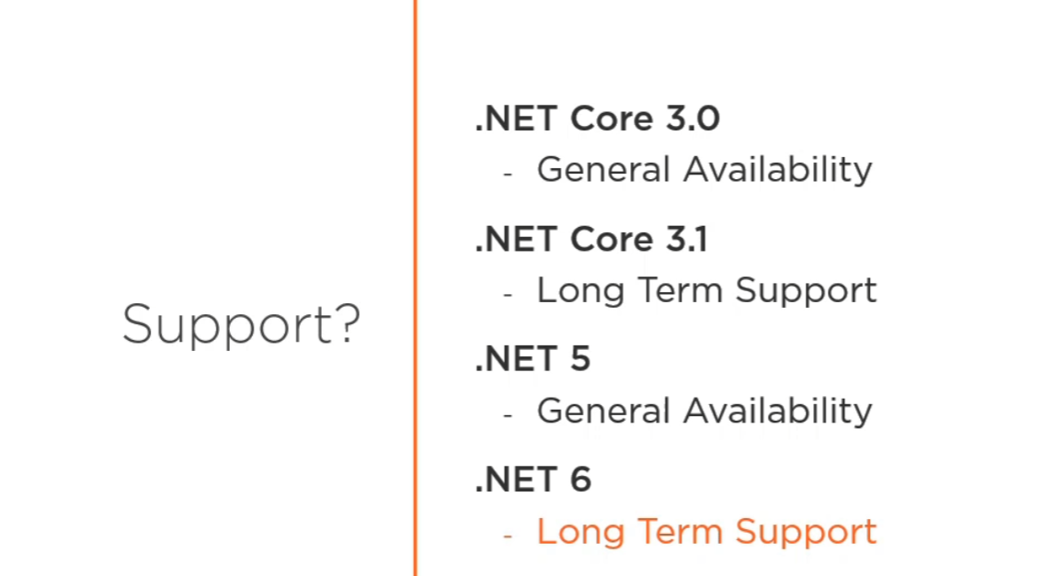

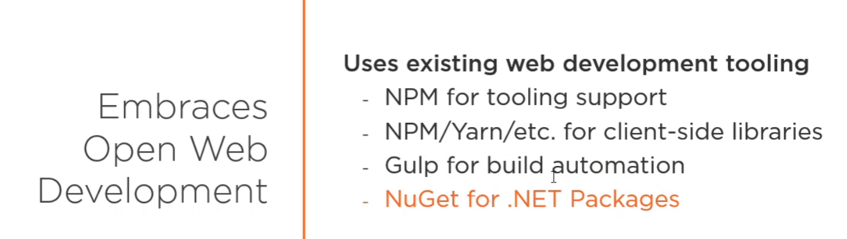

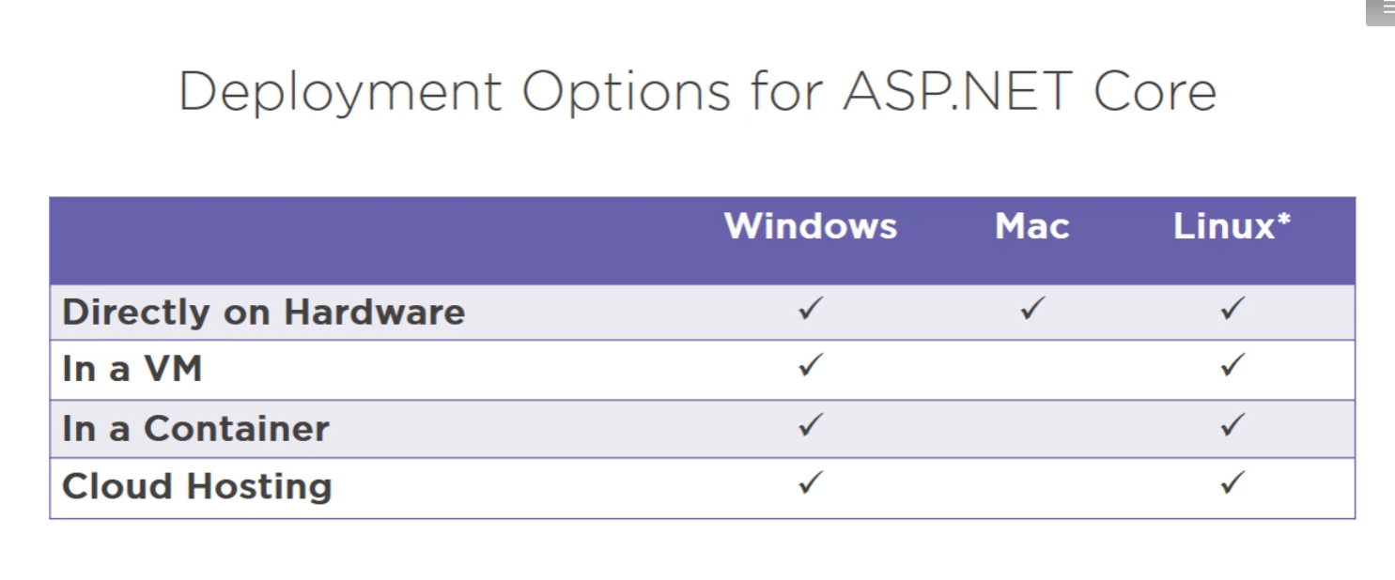

<https://www.backblaze.com/blog/vm-vs-containers/>

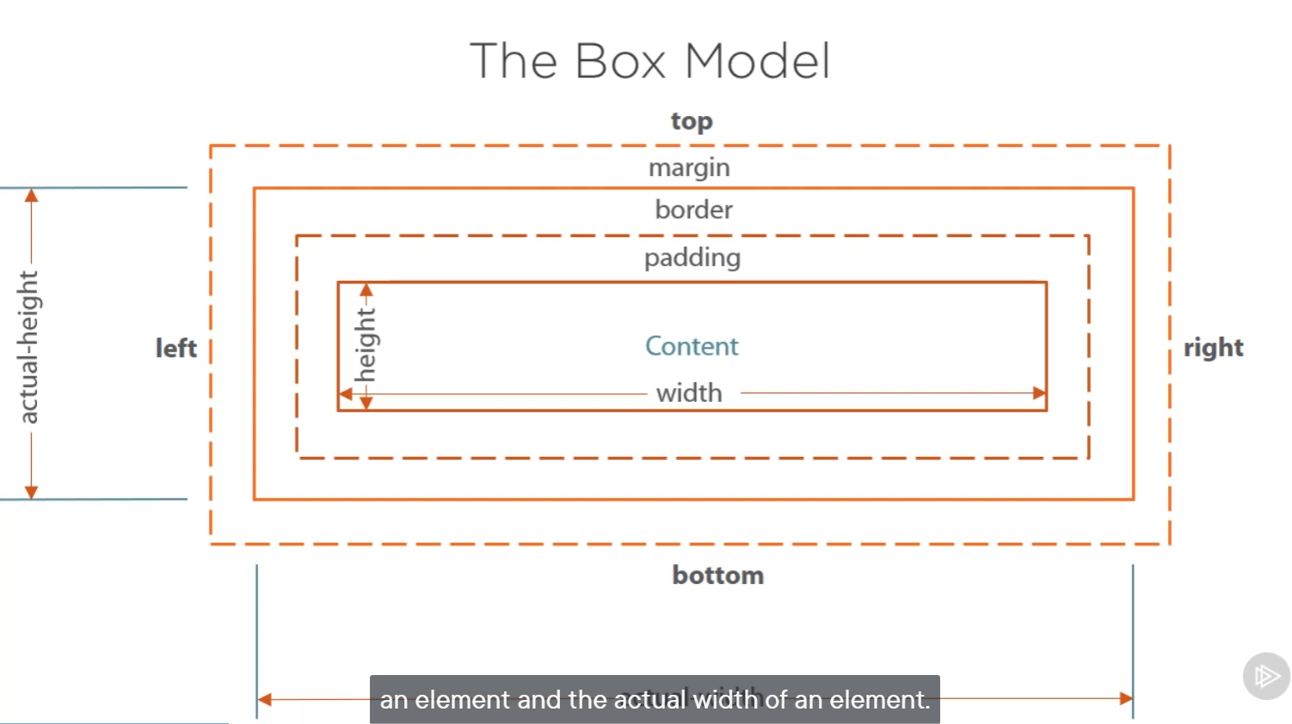

display : Inline-block; only border for content

float : left; take space on left but leave right space for other div element

Add js library suing add new in vs 2019

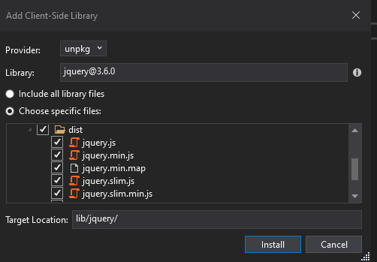

<https://madasamy.medium.com/javascript-brief-history-and-ecmascript-es6-es7-es8-features-673973394df4>

Jquery will detect different browser by itself. Deal with global scope.

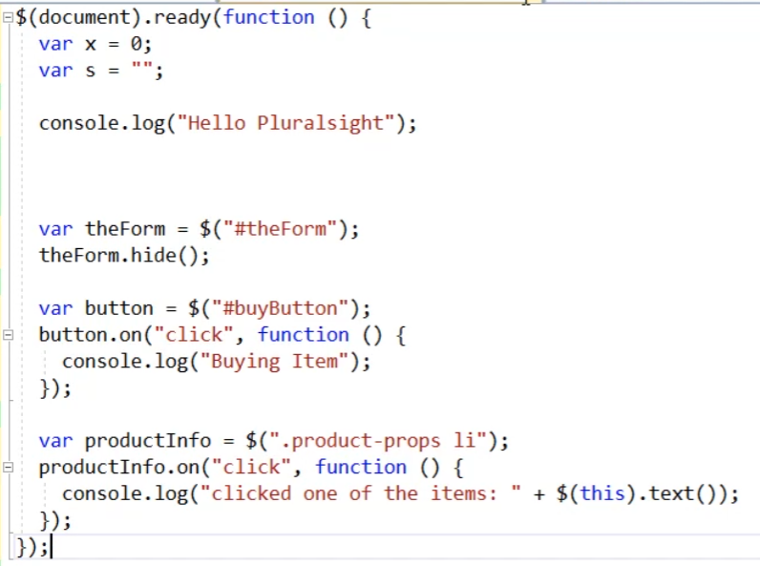

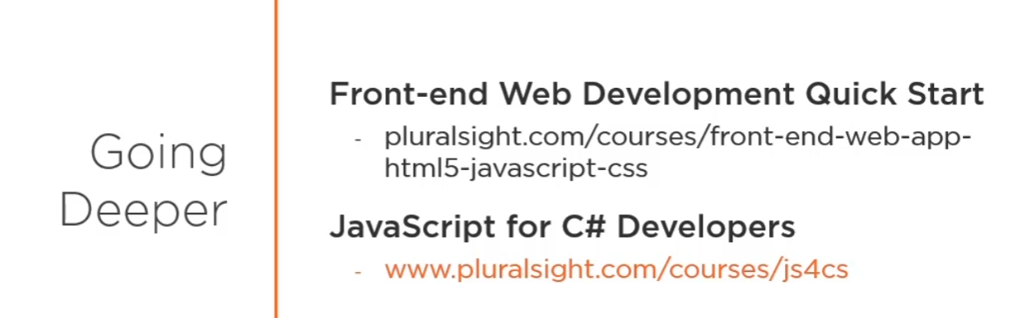

public class ManageController : Controller (base class)

[HttpGet]

public async Task<IActionResult> MyAccount()

{

var user = await _userManager.GetUserAsync(User);

if (user == null)

{

throw new ApplicationException($"Unable to load user with ID '{_userManager.GetUserId(User)}'.");

}

var model = new IndexViewModel

{

Username = user.UserName,

Email = user.Email,

PhoneNumber = user.PhoneNumber,

IsEmailConfirmed = user.EmailConfirmed,

StatusMessage = StatusMessage

};

return View(model);

}

View: has naming convention to Look for a Views->Manager->MyAccount.cshtml

View(model) : return the model data to match with page element

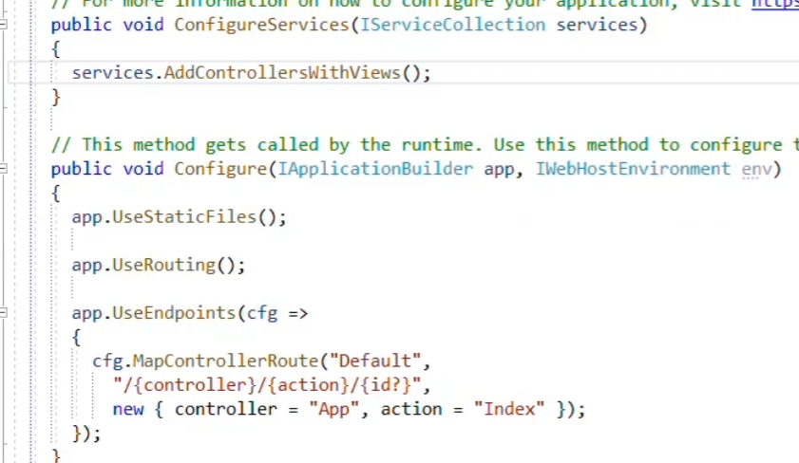

* Added controller view service
* Config default routing : follow up /controller action and id pattern but id could be optional
* Also default controller is App and action is index.cstml
* If(env.IsDevelopment) => match with ASPNETCORE_ENVIRONEMENT settingD

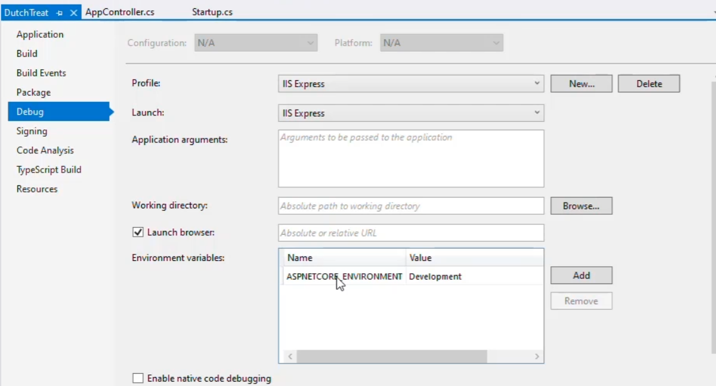

* App.UseDevelopmentExceptionPage() to handle exception

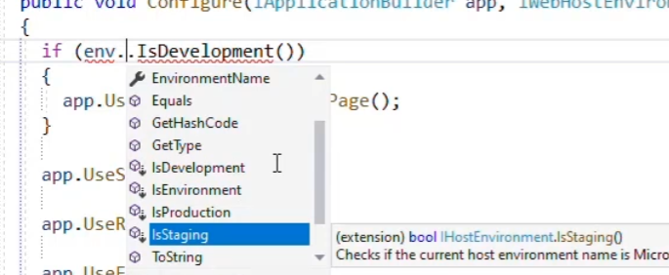

**Chapter 5 Using ASP.NETMVC**

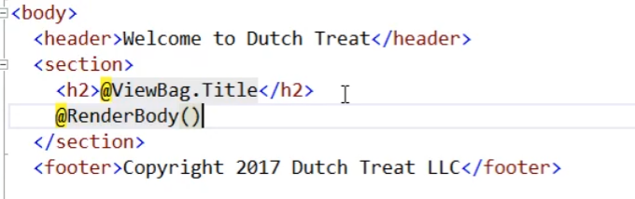

<https://exceptionnotfound.net/asp-net-mvc-demystified-layout-viewstart-renderbody-and-rendersection/#:~:text=RenderBody()%20is%20called%20to,container%20body%2Dcontent%22%3E%20>.

Added CSS and JS to this page Under Views folder

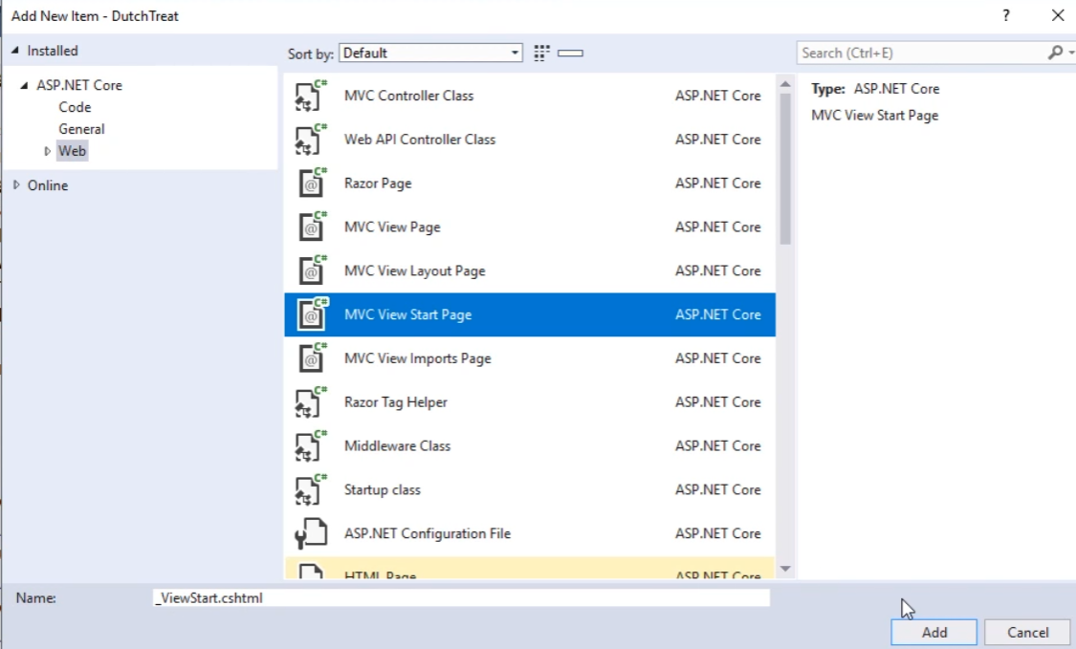

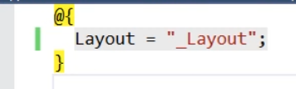

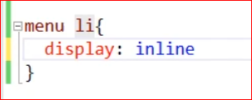

Added tag helper (help hard coded url like app/contact etc) Under Views folder

Add common name spaces for every page

@using Microsoft.eShopWeb.Web

@using Microsoft.eShopWeb.Web.ViewModels

@using Microsoft.eShopWeb.Web.ViewModels.Account

@using Microsoft.eShopWeb.Web.ViewModels.Manage

@using Microsoft.eShopWeb.Web.Pages

@using Microsoft.AspNetCore.Identity

@using Microsoft.eShopWeb.Infrastructure.Identity

@namespace Microsoft.eShopWeb.Web.Pages

@addTagHelper *, Microsoft.AspNetCore.Mvc.TagHelpers 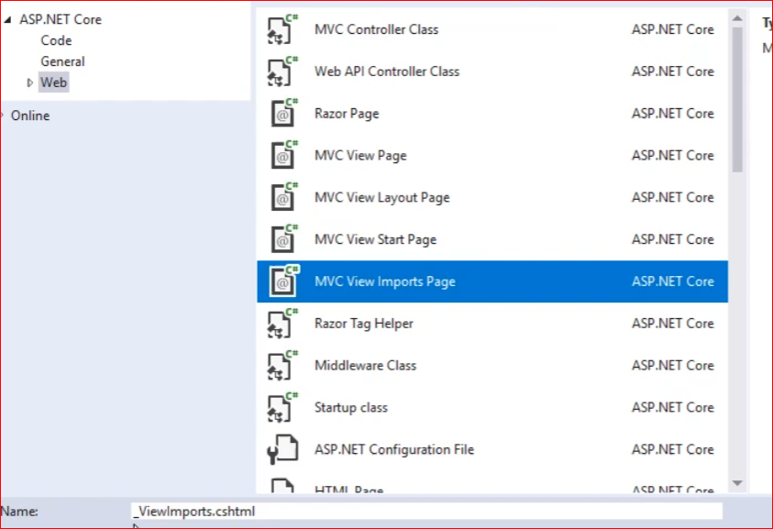

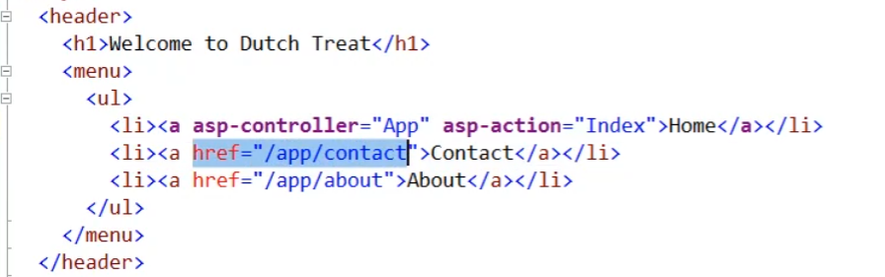

Make link is not fragile

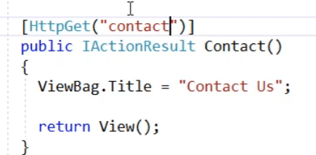

Error page for Production

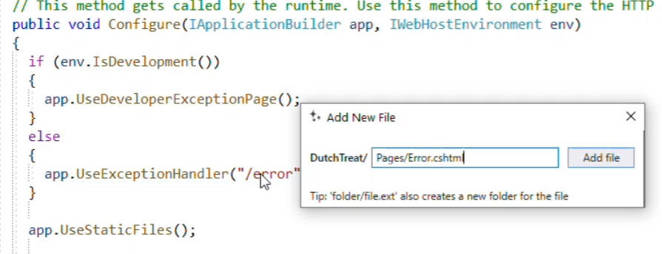

@page into Error.cshtml

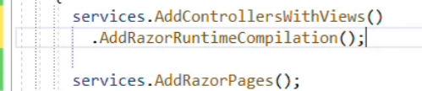

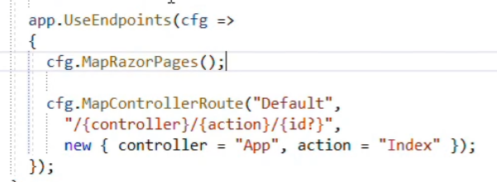

<https://docs.microsoft.com/en-us/aspnet/core/mvc/views/view-compilation?view=aspnetcore-5.0&tabs=visual-studio>

Enable razor page runtime compilation is very important for development

Check form post

Giving name of every fields.

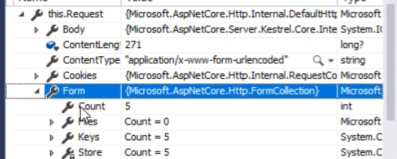

**Model binding**

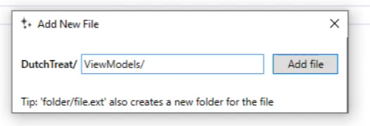

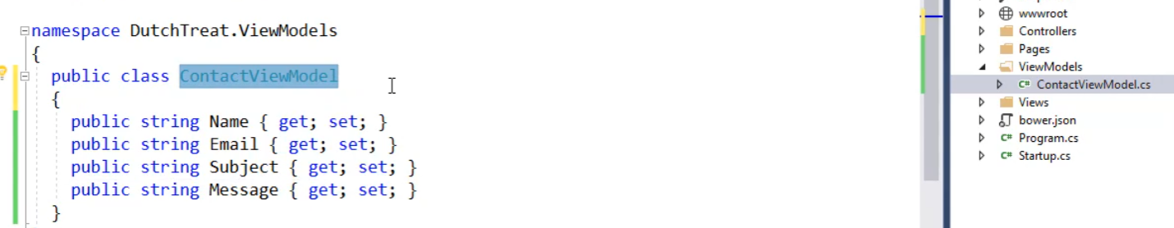

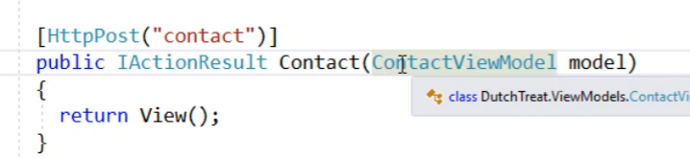

Better

@model ContaatViewModel and add it to _viewImports.cshtml

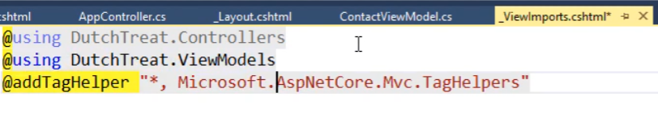

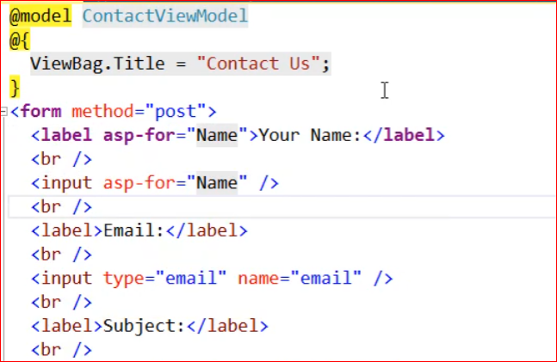

Validation using data annotation

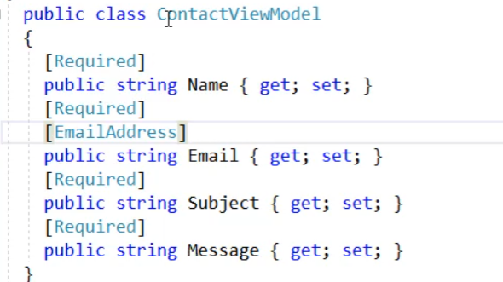

Asp-validation-summery

[error =”too long”] on data annotation

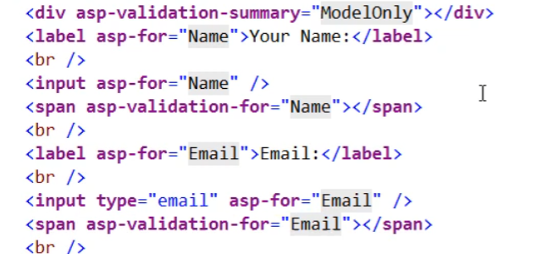

Add Jquery-validaton from client side library

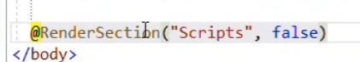

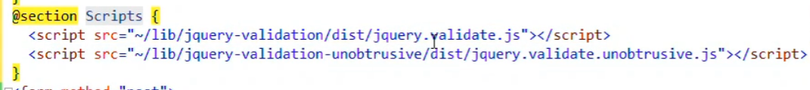

Losing cursor error show up right away

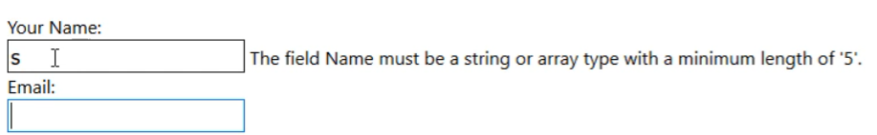

Add service

Singleton: for share state and expensive constructed

Scope : database object for every request

Transient : died after every instance or request

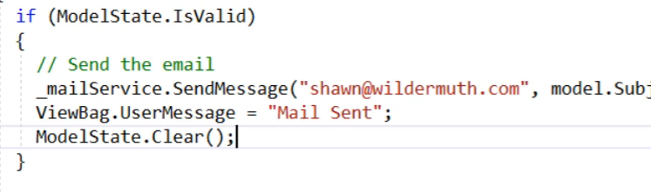

**Chapter 6 Using Bootstrap**

* Added client side library
* Added bootstrap css(top) and js (bottom)to layout file

Add container and give back ground color to test RESPONSIVE version

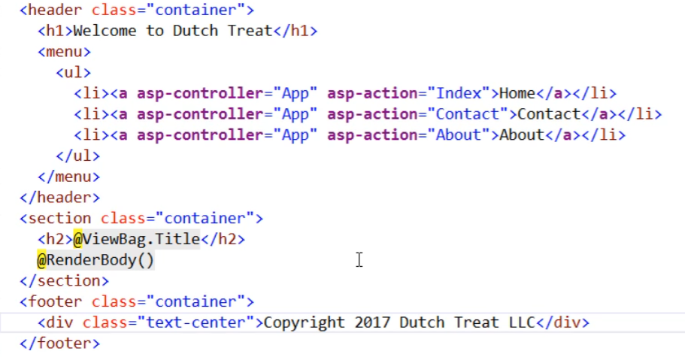

NavBar (md means middle size screen using horizontal)

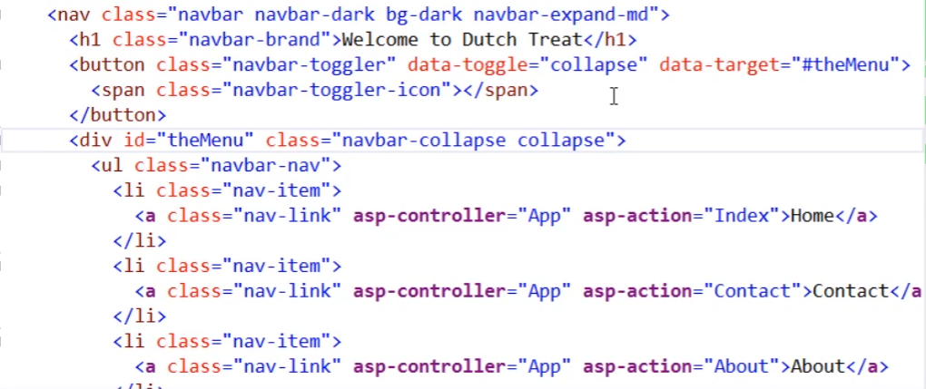

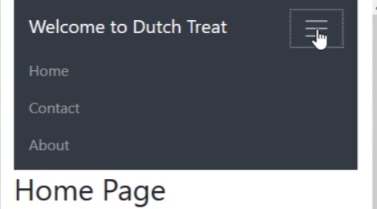

The Bootstrap grid system

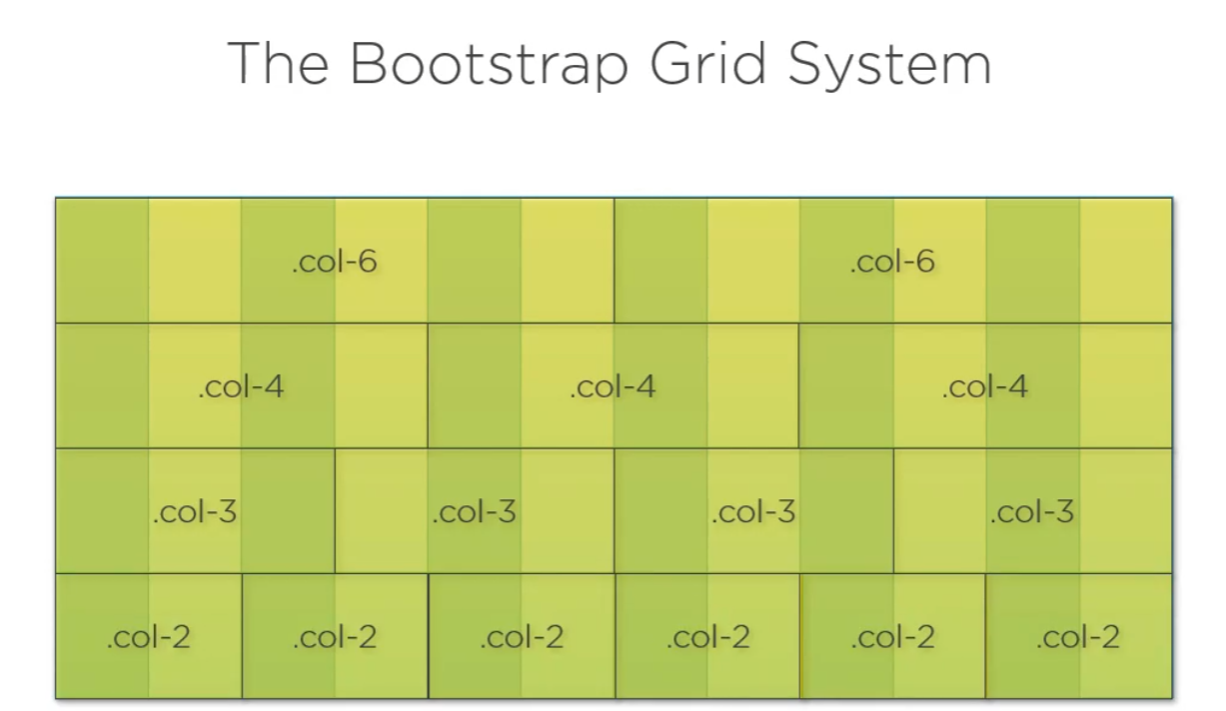

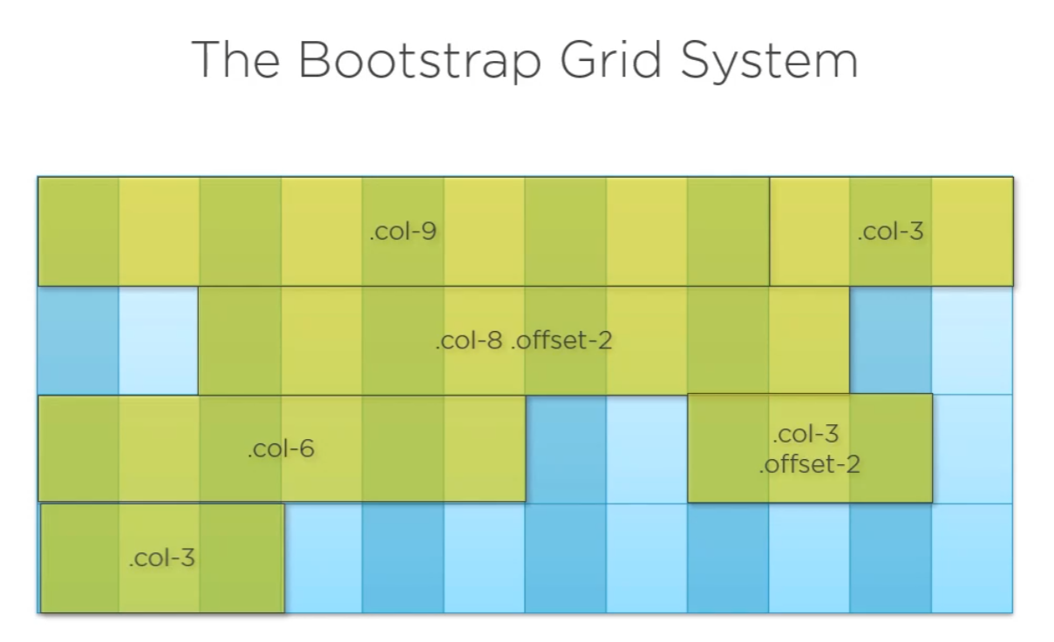

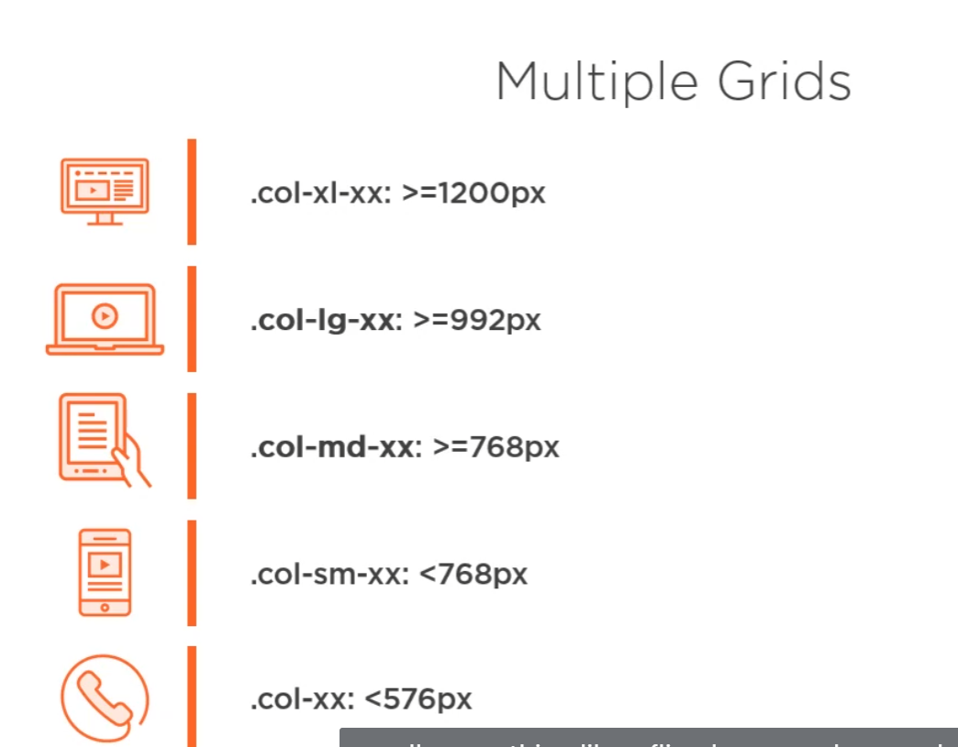

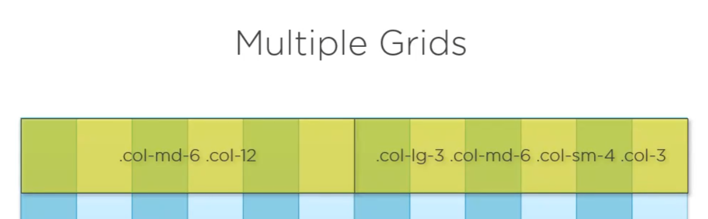

<div calss=”row”>

<div class=”col-md-6”></div>

<div class=”col-md-6”> </div>

</div

Card is just a container

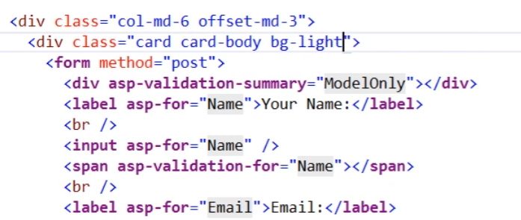

Bootstrap for the form

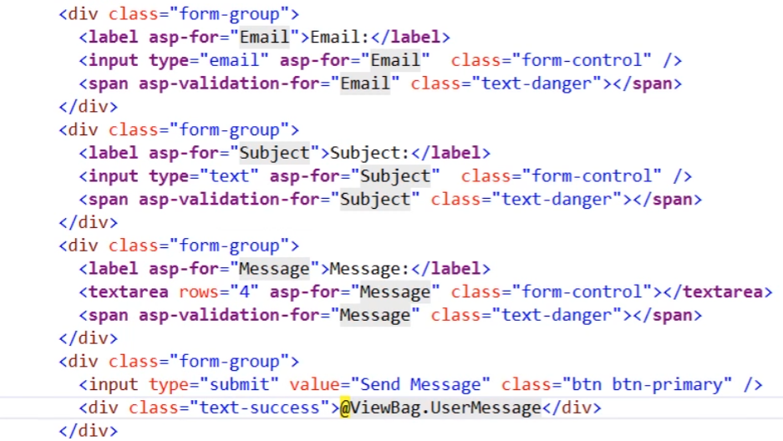

**Use font awesome**

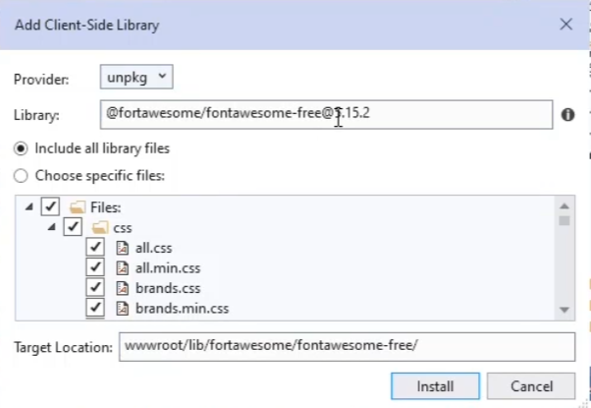

Need css and webfount component only

Better icon



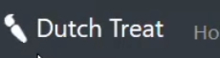

Fas is solid

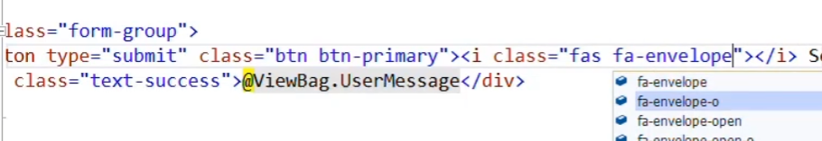

**Chapter 7 Using Entity framework core**

Create seed data

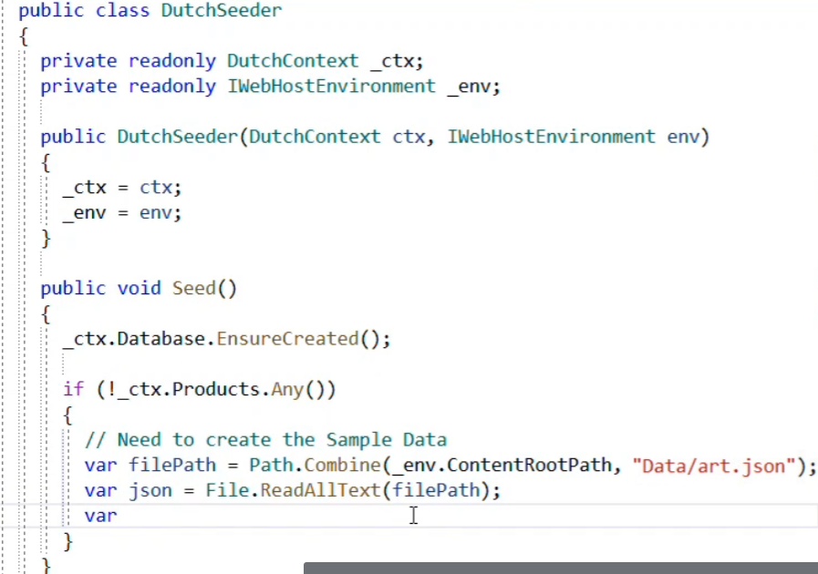

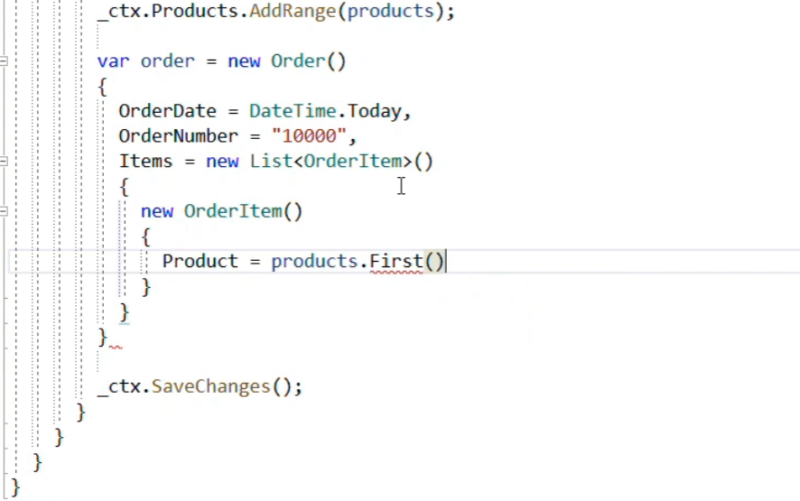

Call seeds function in program.cs

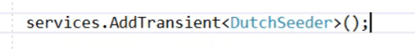

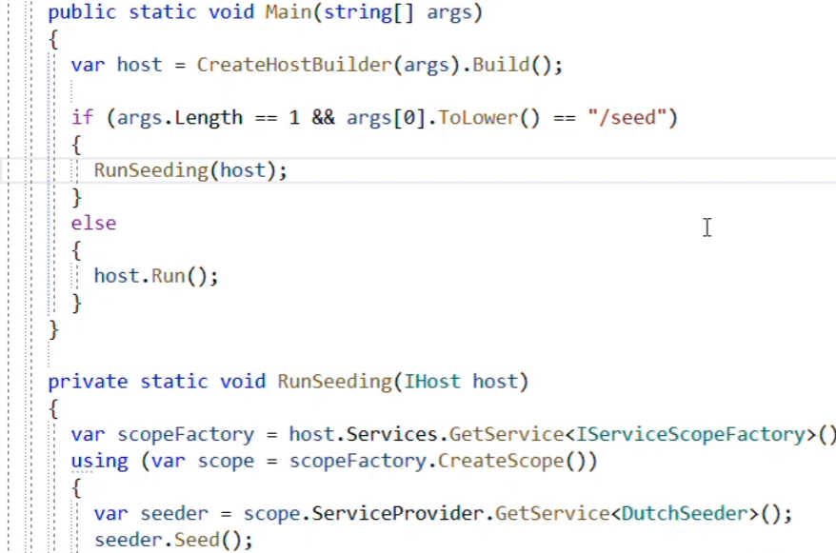

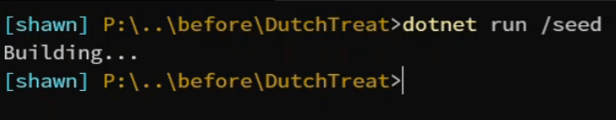

**Repository pattern**

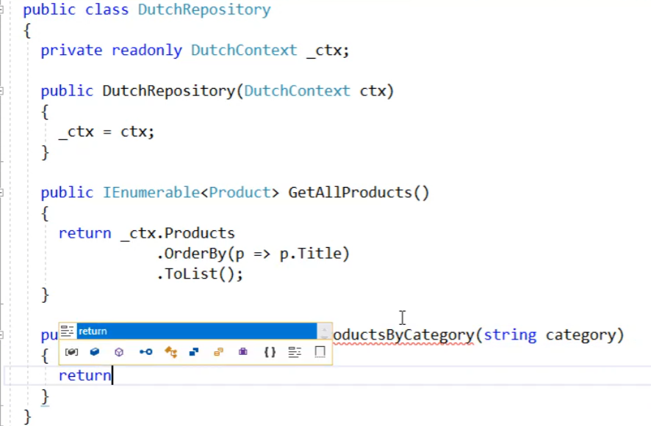

**Logging**

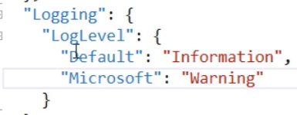

**Chapter 8 Creating API with ASP.Net MVC**

<https://github.com/dotnet/AspNetCore.Docs/tree/main/aspnetcore/web-api/index/samples/3.x>

[ApiController]

[Route("api/[controller]")]

public class ConsumesController : ControllerBase

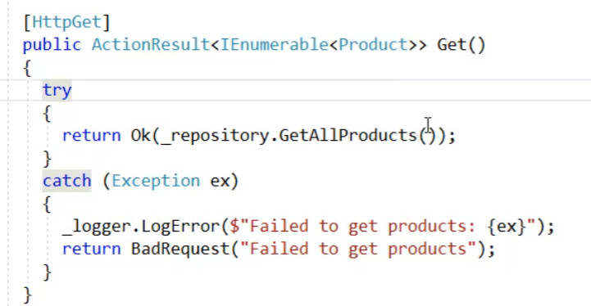

**In case you like to get return from all different data format.**

[**https://docs.microsoft.com/en-us/aspnet/core/web-api/?view=aspnetcore-5.0**](https://docs.microsoft.com/en-us/aspnet/core/web-api/?view=aspnetcore-5.0)

Include to have data collecction

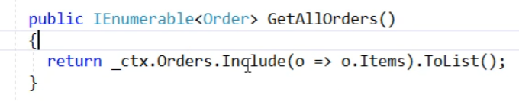

Solve recursive reference issue

Order item has order

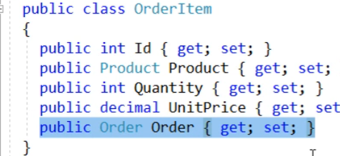

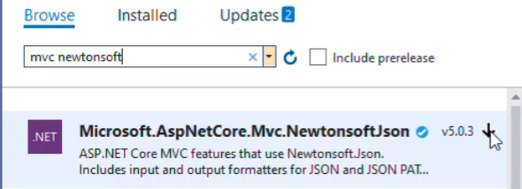

services.AddMvc().AddNewtonsoftJson(options => options.SerializerSettings.ReferenceLoopHandling = ReferenceLoopHandling.Ignore);

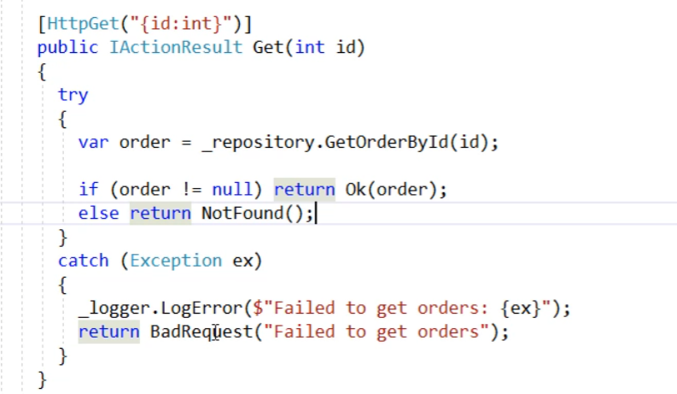

Post; why not put SaveAll to repository of SaveChanges?

public bool SaveAll()

{

return _ctx.SaveChanges() > 0;

}

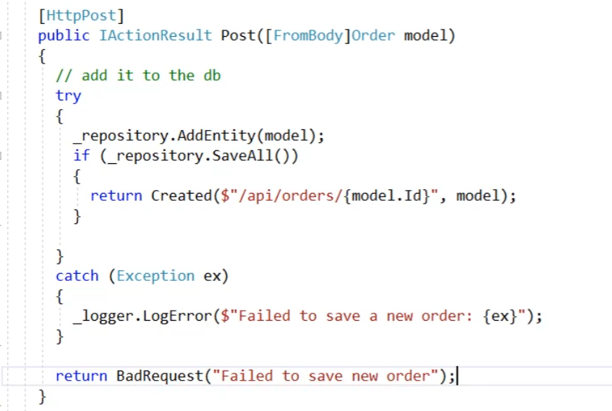

**No-tracking queries**

No tracking queries are useful when the results are used in a read-only scenario.

Validation of view model in API (ModelState)

Automapper between data model and view model

[HttpPost]

public IActionResult Post([FromBody]OrderViewModel model)

{

try

{

if (ModelState.IsValid)

{

var newOrder = _mapper.Map<Order>(model);

if (newOrder.OrderDate == DateTime.MinValue)

{

newOrder.OrderDate = DateTime.Now;

};

_repository.AddEntity(newOrder);

if (_repository.SaveAll())

{

return Created($"/api/orders/{newOrder.Id}", _mapper.Map<OrderViewModel>(newOrder));

}

}

else

{

return BadRequest(ModelState);

}

}

catch (Exception ex)

{

_logger.LogError($"Failed to save new order: {ex}");

}

return BadRequest("Failed to save new order.");

}

public class DutchMappingProfile : Profile

{

public DutchMappingProfile()

{

CreateMap<Order, OrderViewModel>()

.ForMember(o => o.OrderId, ex => ex.MapFrom(i => i.Id))

.ReverseMap();

CreateMap<OrderItem, OrderItemViewModel>()

.ReverseMap();

}

}

Check error place

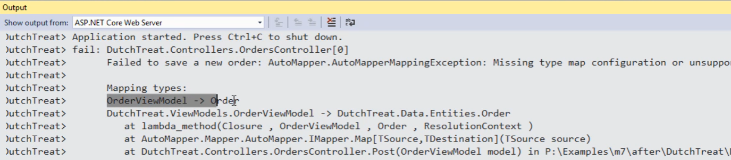

Create query string

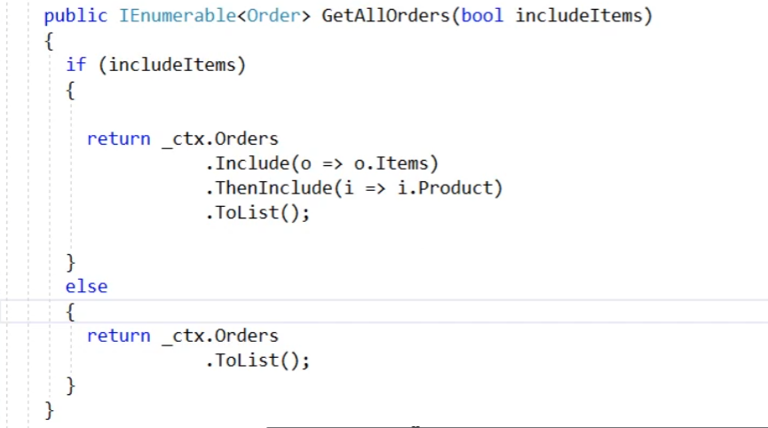

**Chapter 9 ASP.NET Core Identity**

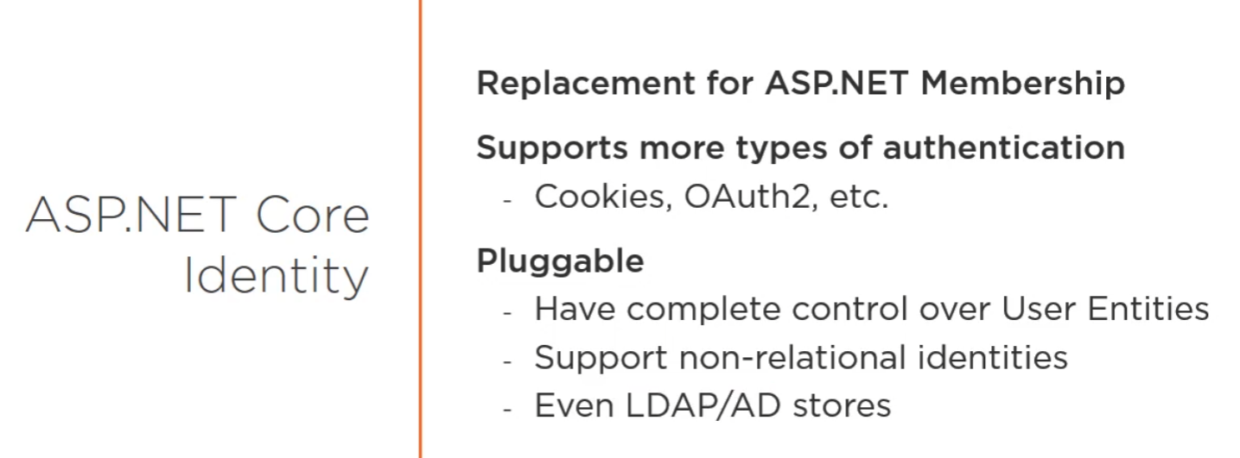

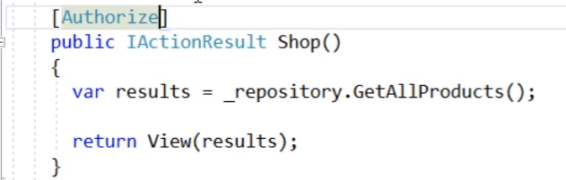

Step 1:

public class StoreUser : IdentityUser

{

public string FirstName { get; set; }

public string LastName { get; set; }

}

Step 2:

public class DutchContext : IdentityDbContext<StoreUser>

Step 3:

public class Order

{

…

public StoreUser User { get; set; }

}

Step 4:

StoreUser user = await _userManager.FindByEmailAsync("shawn@dutchtreat.com");

if (user == null)

{

user = new StoreUser()

{

FirstName = "Shawn",

LastName = "Wildermuth",

Email = "shawn@dutchtreat.com",

UserName = "shawn@dutchtreat.com"

};

var result = await _userManager.CreateAsync(user, "P@ssw0rd!");

if (result != IdentityResult.Success)

{

throw new InvalidOperationException("Could not create new user in Seeder");

}

}

Step 5:

seeder.SeedAsync().Wait();

Step 6:

Configure identity

services.AddIdentity<StoreUser, IdentityRole>(cfg =>

{

cfg.User.RequireUniqueEmail = true;

})

.AddEntityFrameworkStores<DutchContext>();

services.AddAuthentication()

.AddCookie()

.AddJwtBearer(cfg =>

{

cfg.TokenValidationParameters = new TokenValidationParameters()

{

ValidIssuer = _config["Tokens:Issuer"],

ValidAudience = _config["Tokens:Audience"],

IssuerSigningKey = new SymmetricSecurityKey(Encoding.UTF8.GetBytes(_config["Tokens:Key"]))

};

});

app.UseAuthentication();

app.UseAuthorization();

**Impalement Login page**

public class AccountController : Controller

**Cookie to access API is not a good practice. JWT is a choice.**

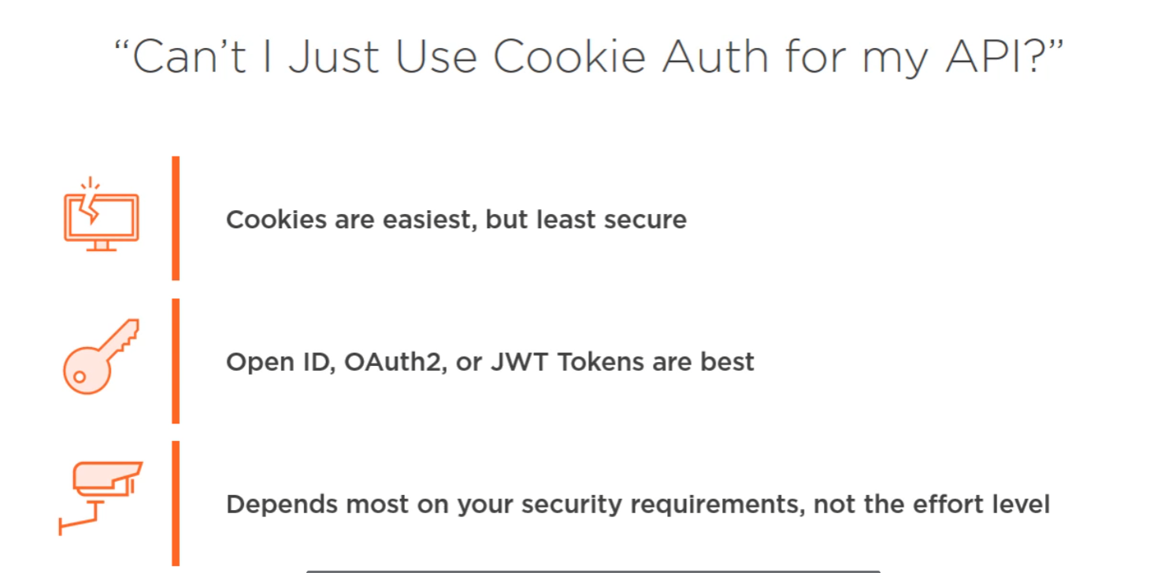

services.AddAuthentication()

.AddCookie()

.AddJwtBearer(cfg =>

{

cfg.TokenValidationParameters = new TokenValidationParameters()

{

ValidIssuer = _config["Tokens:Issuer"],

ValidAudience = _config["Tokens:Audience"],

IssuerSigningKey = new SymmetricSecurityKey(Encoding.UTF8.GetBytes(_config["Tokens:Key"]))

};

});

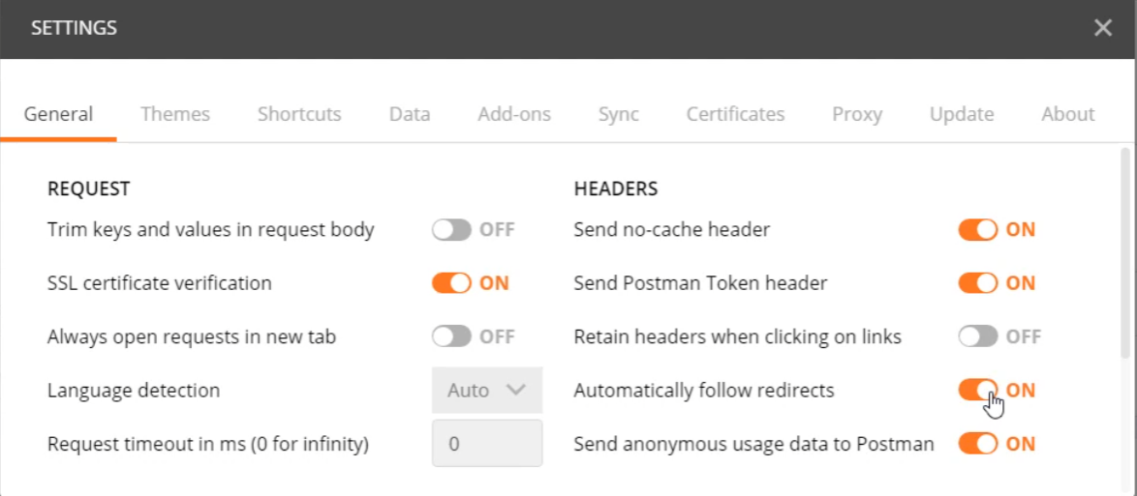

[Authorize(AuthenticationSchemes = JwtBearerDefaults.AuthenticationScheme)]

Use postmain to call this API to get JWT

[HttpPost]

public async Task<IActionResult> CreateToken([FromBody] LoginViewModel model)

Get token from postman

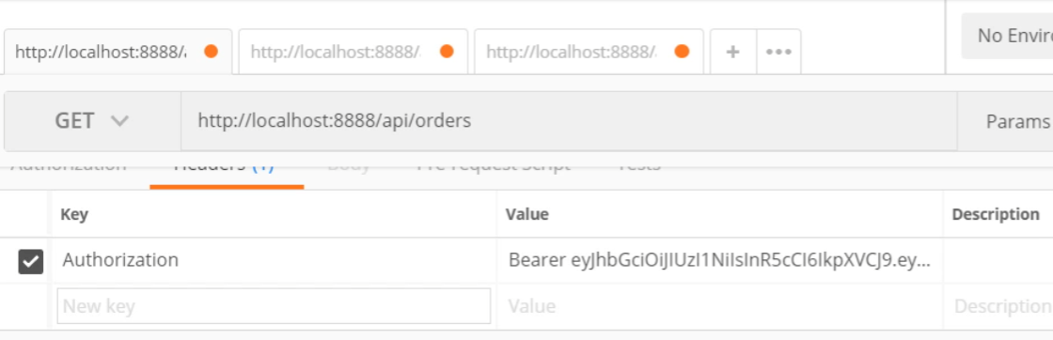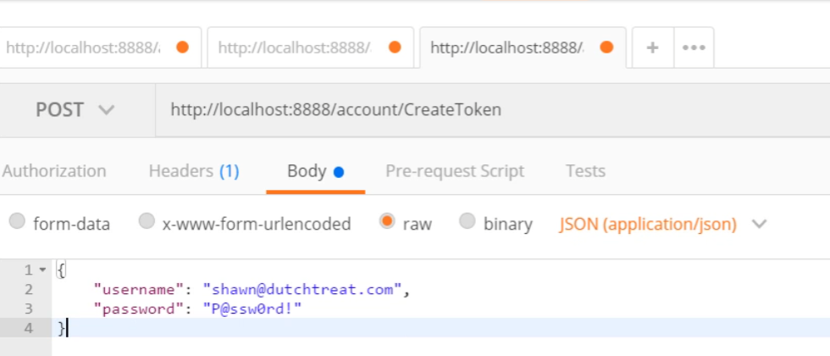

Post order with user

var currentUser = await _userManager.FindByNameAsync(User.Identity.Name);

newOrder.User = currentUser;

**Chapter 10 Typescript**

* Supper set of Typescript; will be compiled to js
* Know the error during compilation

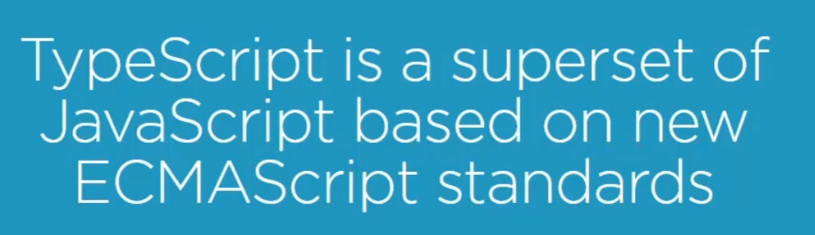

<https://caniuse.com/>

Step 1

class Shopper {

constructor(private firstName: string, private lastName: string) {

}

showName() {

alert(`${this.firstName} ${this.lastName}`);

}

}

const shopper = new Shopper("Shawn", "Wildermuth");

shopper.showName();

Step 2

Compilation settings in tsconfig.json

{

"include": [ "wwwroot/ts/**/*.ts" ],

"compileOnSave": true,

"compilerOptions": {

"module": "None",

"sourceMap": true

}

}

Step 3

@section Scripts {

<script src="~/ts/shopper.js"></script>

<script src="~/ts/main.js"></script>

}

**Chapter 11 Client side development with Angular**

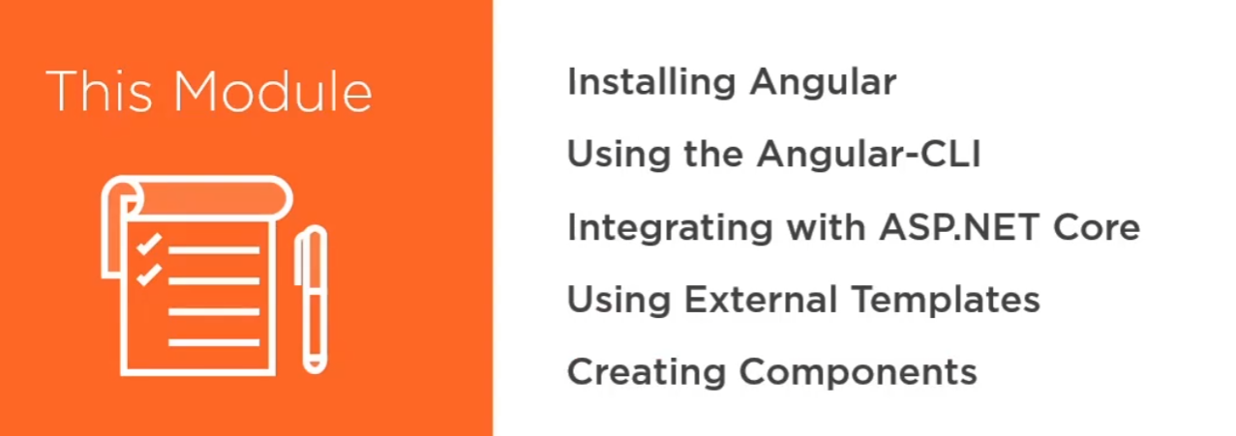

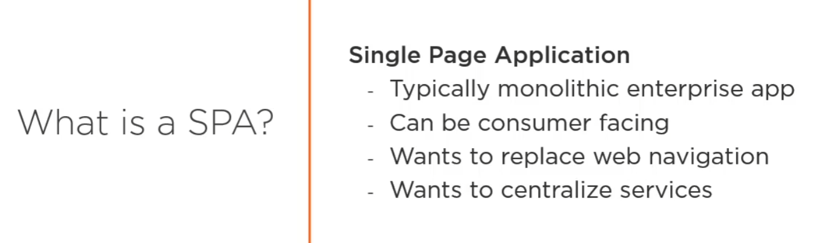

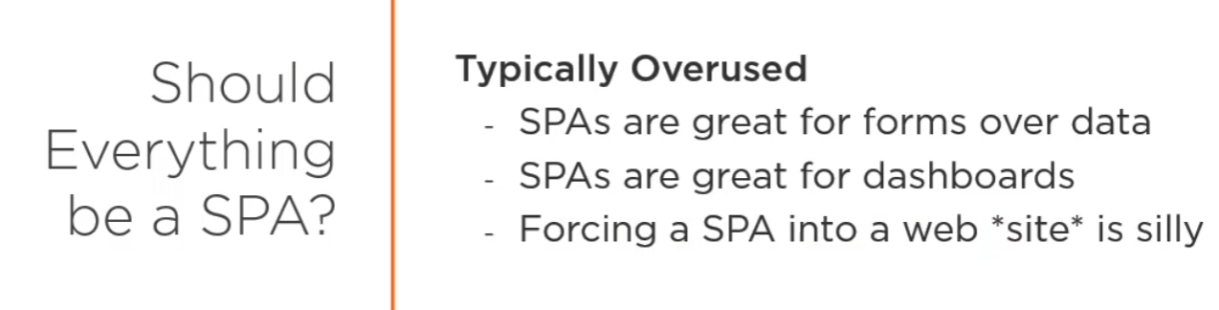

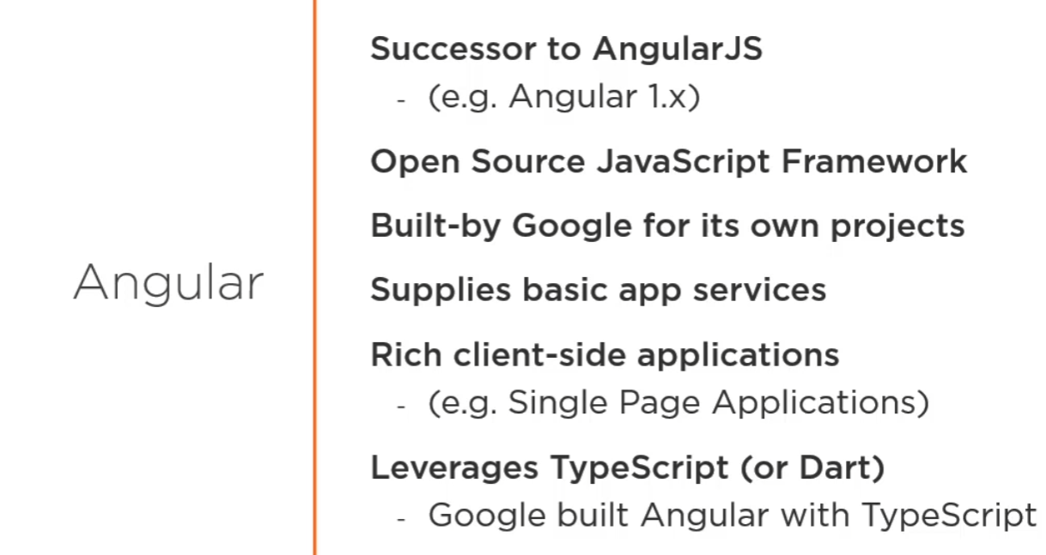

Step 1: Install angular cli



Step 2: ng new client –-skip-git –skip-tests –-minumal –-default **–-dry-run**

Step 3: ng build

Step 4: ng serve

Step 5: change one line code and rebuild

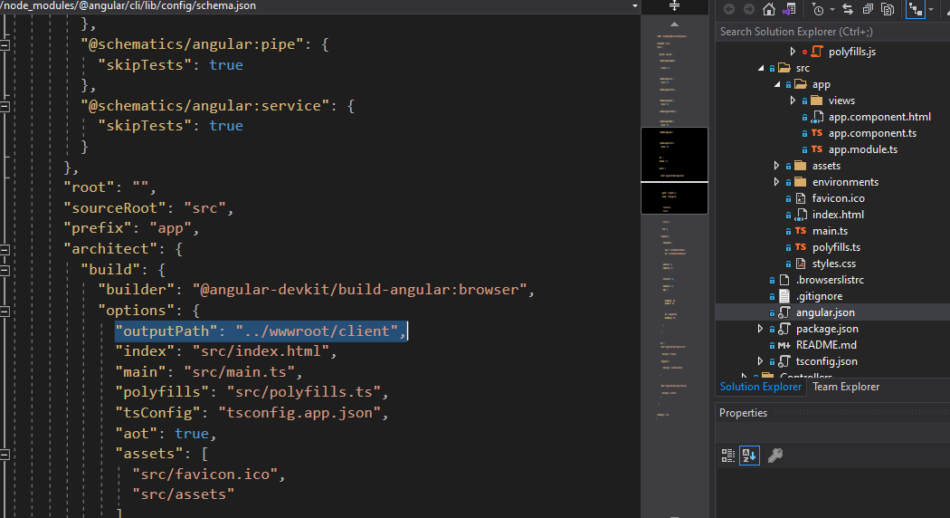



Step 6: client folder is created under [www.root](http://www.root)

**Integrated to project**

**Step 1: Shop.cshtml**

@section Scripts {

<script src="~/client/vendor.js"></script>

<script src="~/client/polyfills.js"></script>

<script src="~/client/runtime.js"></script>

<script **src**="~/client/main.js" **asp-append-version**="true"></script>

}

@section head {

<link href="~/client/styles.css" rel="stylesheet" />

}

<the-shop></the-shop>

**Step 2: _layout.cshtml**

@RenderSection("head", false)

Step 3: app.component.ts

import { Component } from '@angular/core';

@Component({

selector: 'the-shop',

templateUrl: "app.component.html",

styles: []

})

export class AppComponent {

title = 'Shop';

}

**First component**

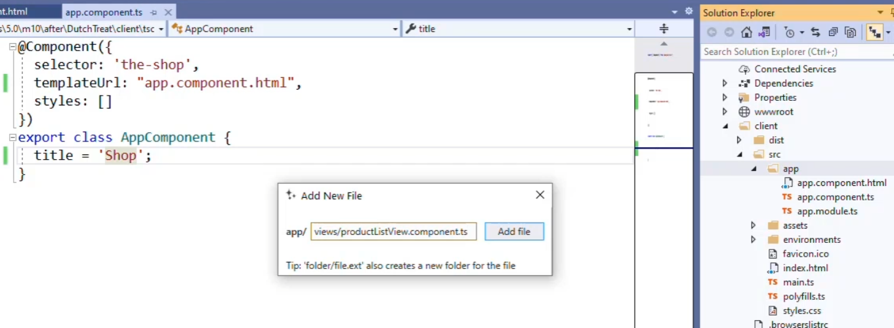

* productListView.component.ts

import { Component } from "@angular/core"; //decorator from ctrl + .

@Component({

selector: "product-list",

templateUrl: "productListView.component.html"

})

export default class ProductListView {

public products = [{

title: "Van Gogh Mug",

price: "19.99"

}, {

title: "Van Gogh Poster",

price: "29.99"

}];

}

* productListView.component.html

<div class="row">

<ul>

<li *ngFor="let p of products">**{{** p.title **}}**: $**{{** p.price **}}**</li> ngFor directive

</ul>

</div>

* app.component.ts

import { NgModule } from '@angular/core';

import { BrowserModule } from '@angular/platform-browser';

import { AppComponent } from './app.component';

import ProductListView from './views/productListView.component';

@NgModule({

declarations: [

AppComponent,

ProductListView

],

imports: [

BrowserModule

],

providers: [],

bootstrap: [AppComponent]

})

export class AppModule { }

* app.component.html

<div class="row">

<div class="col-9">

<h3>**{{** title **}}**</h3>

<product-list></product-list>

</div>

<div class="col-3">

<h3>Cart</h3>

</div>

</div>

**Chapter 12 Using Service in Angular**

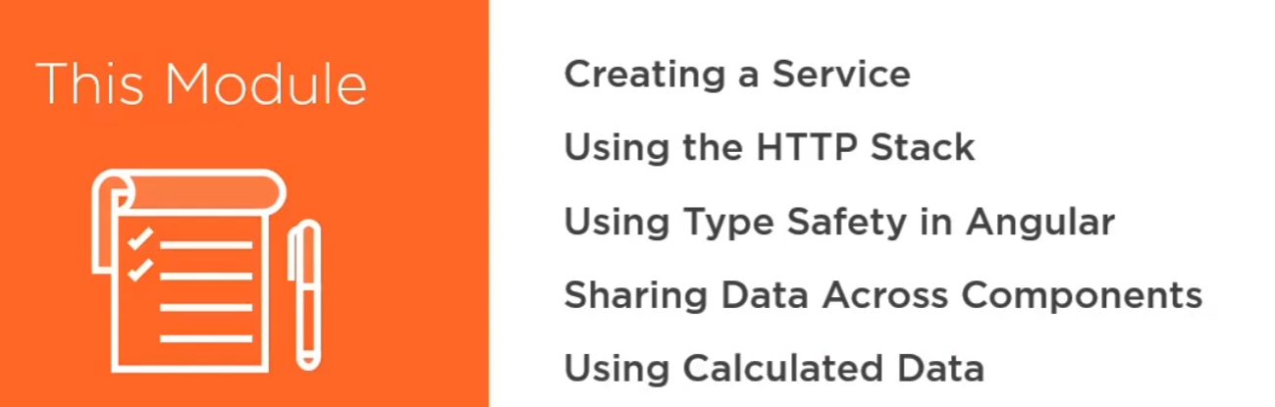

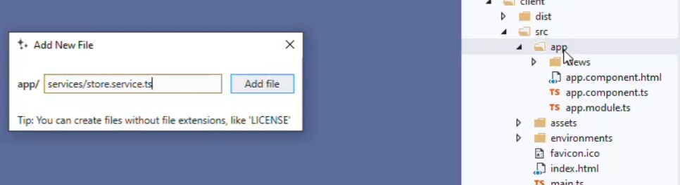

Step 1 : create service

import { HttpClient } from "@angular/common/http";

import { Injectable } from "@angular/core";

import { Observable } from "rxjs";

import { map } from "rxjs/operators";

import { Order, OrderItem } from "../shared/Order";

import { Product } from "../shared/Product";

@Injectable()

export class Store {

constructor(private http: HttpClient) {

}

public products: Product[] = [];

public order: Order = new Order();

loadProducts(): Observable<void> {

return this.http.get<[]>("/api/products")

.pipe(map(data => {

this.products = data;

return;

}));

}

addToOrder(product: Product) {

let item: OrderItem;

item = this.order.items.find(o => o.productId === product.id);

if (item) {

item.quantity++;

} else {

item = new OrderItem();

item.productId = product.id;

item.productTitle = product.title;

item.productArtId = product.artId;

item.productArtist = product.artist;

item.productCategory = product.category;

item.productSize = product.size;

item.unitPrice = product.price;

item.quantity = 1;

this.order.items.push(item);

}

}

Step 2: create input component

productListView.component.html

Step 3:

@NgModule({

declarations: [

AppComponent,

ProductListView,

CartView

],

imports: [

BrowserModule,

HttpClientModule

],

providers: [

Store

],

bootstrap: [AppComponent]

})

export class AppModule { }

[**http://json2ts.com/**](http://json2ts.com/) **to get export class0**

export class Product {

id: number;

category: string;

size: string;

price: number;

title: string;

artDescription: string;

artDating: string;

artId: string;

artist: string;

artistBirthDate: Date;

artistDeathDate: Date;

artistNationality: string;

}

public products: Product[] = [];

**Chapter 13 Routing with Angular**

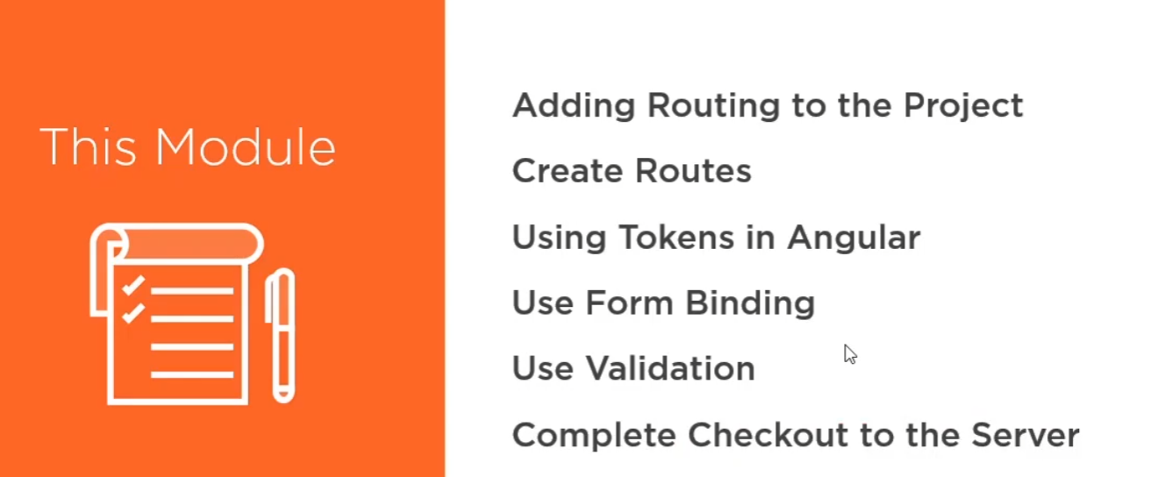

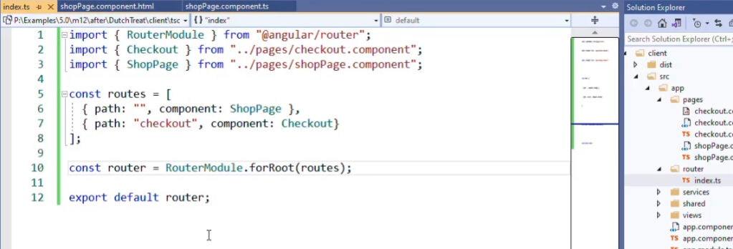

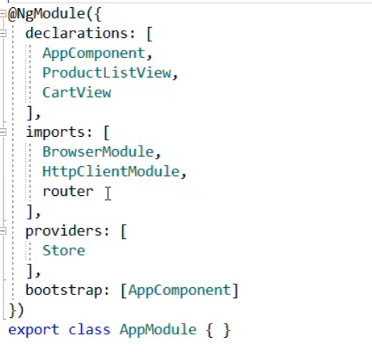

const routes = [

{ path: "", component: ShopPage },

{ path: "checkout", component: CheckoutPage, canActivate: [AuthActivator] },

{ path: "login", component: LoginPage },

{ path: "**", redirectTo: "/" }//no router works, back to shop page

];

const router = RouterModule.forRoot(routes, {

useHash: false

});

@section head {

<base href="/App/Shop" />

<link href="~/client/styles.css" rel="stylesheet" />

}

<a class="btn btn-success" *ngIf="store.order.items.length > 0" routerLink="checkout">Checkout</a>

**Authentication before checkout**

public token = "";

public expiration = new Date();

get loginRequired(): boolean {

return this.token.length === 0 || this.expiration > new Date();

}

export class AuthActivator implements CanActivate {

constructor(private store: Store, private router: Router) {

}

canActivate(route: ActivatedRouteSnapshot,

state: RouterStateSnapshot): boolean | UrlTree | Observable<boolean | UrlTree> | Promise<boolean | UrlTree> {

if (this.store.loginRequired) {

this.router.navigate(["login"])

return false;

} else {

return true;

}

}

}

**Login Form**

2 way binding

<form (submit)="onLogin()">

<div class="form-group">

<label for="username">Username</label>

<input type="text" class="form-control" name="name" #username="ngModel" [(ngModel)]="creds.username" required />

</div>

<div>**{{** creds | json **}}**</div>

imports: [

BrowserModule,

HttpClientModule,

router,

FormsModule

],

**Validation for form**

<div class="text-danger" *ngIf="username.touched && username.invalid && username.errors.required">Required</div>

#username is temporary variable

<input type="submit" class="btn btn-success" value="Login" [disabled]="username.invalid || password.invalid" />

**Use Token Authentication**

export class LoginResults {

token: string;

expiration: Date;

}

export class LoginRequest {

username: string;

password: string;

}

public creds: LoginRequest = {

username: "",

password: ""

}

login(creds: LoginRequest) {

return this.http.post<LoginResults>("/account/createtoken", creds)

.pipe(map(data => {

this.token = data.token;

this.expiration = data.expiration;

}));

}

onLogin() {

this.store.login(this.creds)

.subscribe(() => {

// Successfully logged in

if (this.store.order.items.length > 0) {

this.router.navigate(["checkout"]);

} else {

this.router.navigate([""]);

}

}, error => {

console.log(error);

this.errorMessage = "Failed to login";

});

}

**Enable Complete Purchase button**

checkout() {

const headers = new HttpHeaders().set("Authorization", `Bearer ${this.token}`);

return this.http.post("/api/orders", this.order, {

headers: headers

})

.pipe(map(() => {

this.order = new Order();

}));

}

onCheckout() {

this.errorMessage = "";

this.store.checkout()

.subscribe(() => {

this.router.navigate(["/"]);

}, err => {

this.errorMessage = `Failed to checkout: ${err}`;

})

}

**Add ProductId**

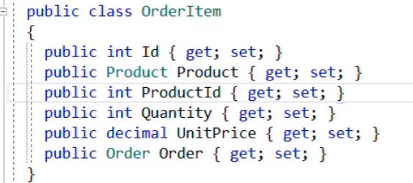

**Ignore product if it exists**

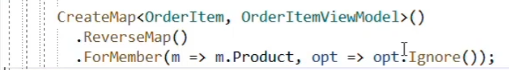

**Chapter 14 deployment**

Use Gulp

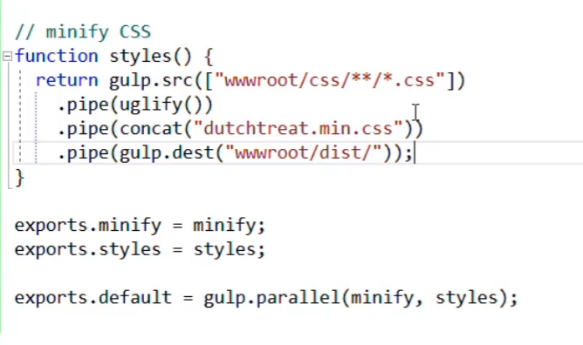

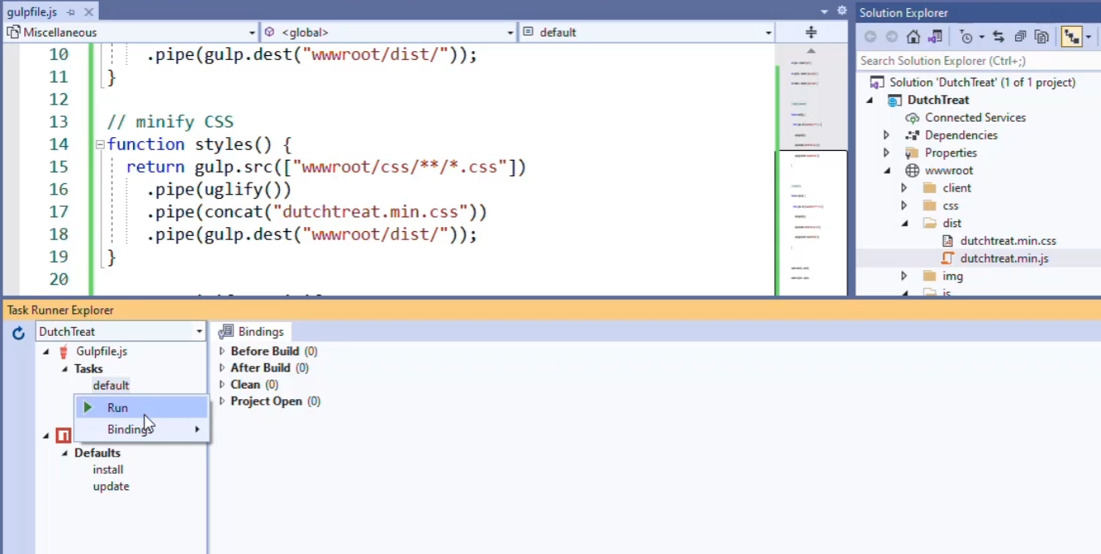

<https://marketplace.visualstudio.com/items?itemName=MadsKristensen.NPMTaskRunner>

Use Environment

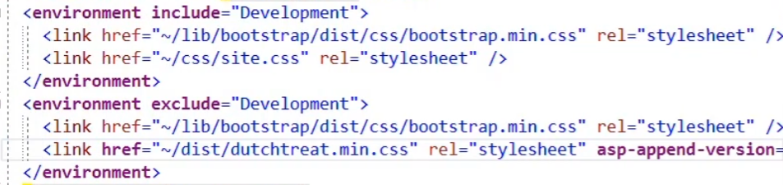

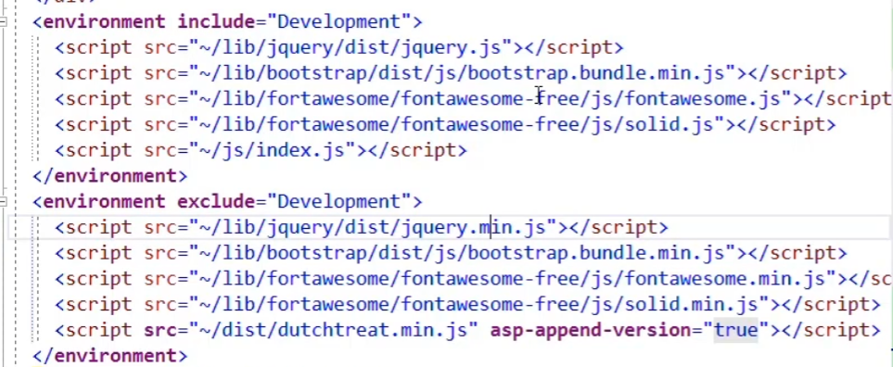

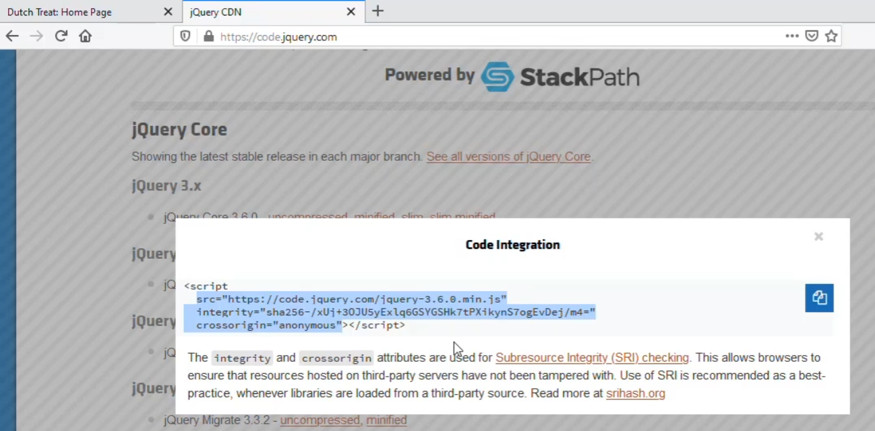

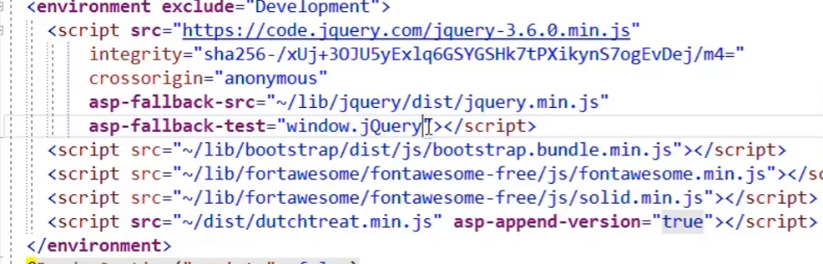

Deployment script

Open project file csproj

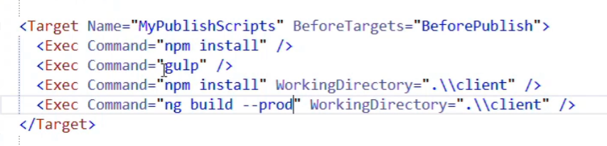

**Dotnet xxx.dll you will get error on angular page**

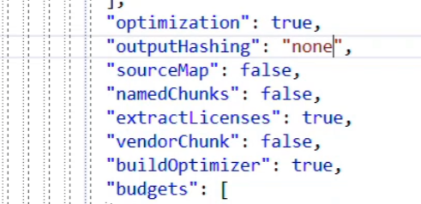

**CLI deployment**

Dotnet publish –o c:\directory

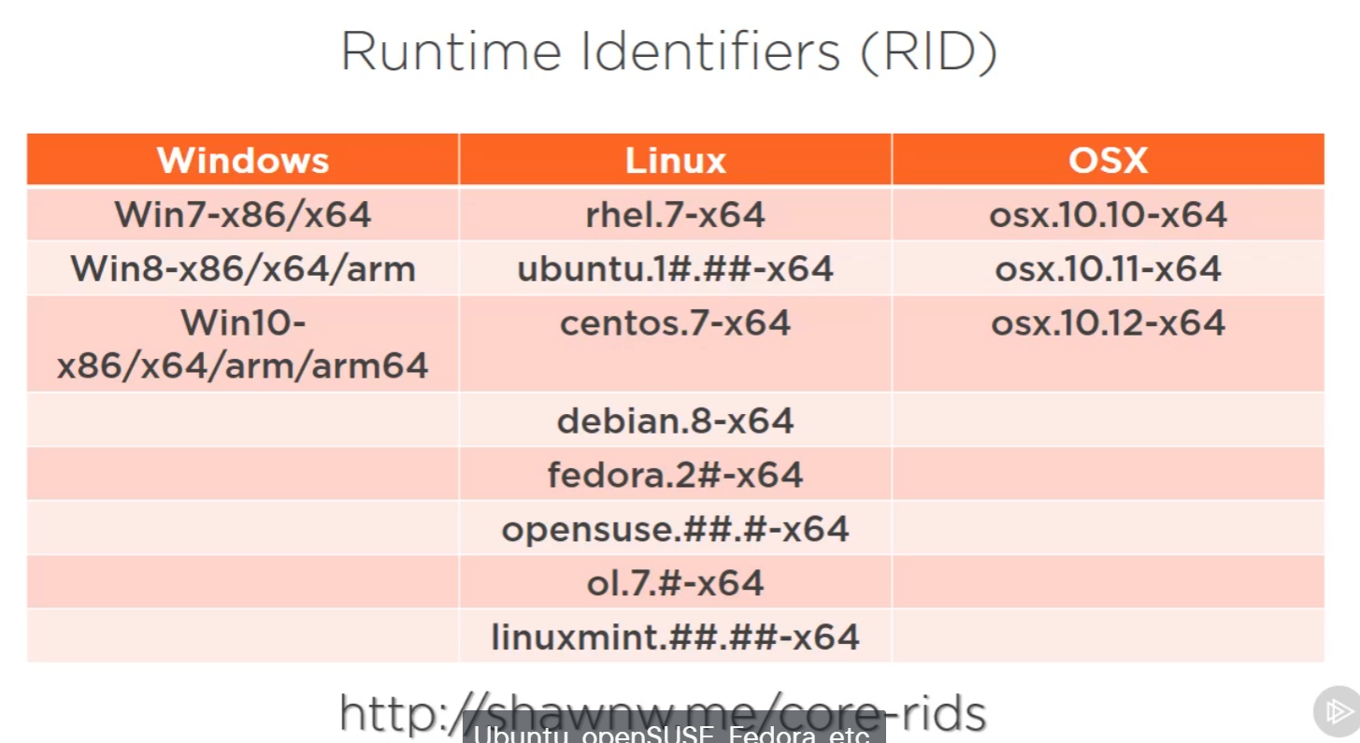

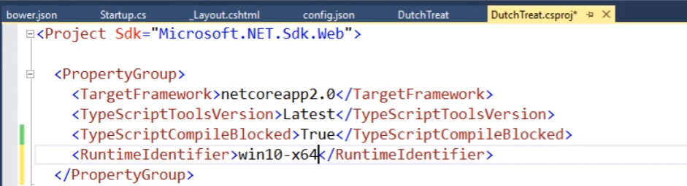

**Dotnet publish –o c:\directory –-self-contained**

**You will get all system files**

**Run it by dutchtreet**

**Dotnet publish –o c:\directory –-runtime XXXXXX**